

|  |  |
| --- | --- |
| Document type | Manual |
| Title | MotoSuiveur® manual |
| Reference | 057-Ternium |
| Author | Dimitar Georgiev |
| Approved by | Yavor Pachov |
| Last revision date | 07/04/2021 |

**Contents**

***1*** ***Introduction*** 4

2 ***Glossary*** 5

***3*** ***Connect MS to control cabinet*** 9

***4*** ***Indication lamps and controls*** 16

***4.1.1*** ***Hoist enabled.*** 17

***4.1.2*** ***Fault*** 17

***4.1.3*** ***Upward enable/Downward enable*** 19

***4.1.4*** ***Backup/Recovery Off/On; Backup/Recovery Down/Up*** 20

***4.1.5*** ***Enable Override*** 20

***4.1.6*** ***Lamp states*** 20

***5*** ***MS operating modes*** 21

***5.1*** ***MS controller internal check*** 21

***5.2*** ***Self-test operation mode*** 21

***5.2.1*** ***Electrical test*** 23

***5.2.2*** ***Switch test*** 24

***5.2.3*** ***Play test*** 25

***5.3*** ***Following operation mode*** 26

***5.4*** ***Backup/Recovery operation mode*** 29

***6*** ***Troubleshoot and maintenance*** 32

***6.1*** ***Troubleshooting via MS controller 7 – segment display*** 32

***6.1.1*** ***MS controller internal errors*** 32

***6.1.2*** ***MS faults and warnings*** 34

***6.2*** ***MSHMI*** 36

***6.3*** ***Maintenance*** 37

***7*** ***Appendix 1: Signal Lamps*** 40

***8*** ***Appendix 2: Spare parts*** 44

***8.1*** ***Electrical spare parts*** 44

***8.2*** ***Mechanical Spares Parts*** 45

***9*** ***Appendix 3: Technical data*** 47

***9.1*** ***MS Motor*** 47

***9.2*** ***Recovery motor*** 51

***Revision history***

|  |  |  |  |
| --- | --- | --- | --- |
| Revision | Description | Revision date | Author |
| A | Initial version | 07.04.2021 | DG |
|  |  |  |  |
|  |  |  |  |
|  |  |  |  |
|  |  |  |  |

# ***Introduction***

Object of this manual is to present operation modes of MotoSuiveur® (for shortly further called MS). Manual describes electrical part of MS, MS operation modes, troubleshooting and maintenance. On figure 1 is presented general principle of MS application. On figure 2 is shown block diagram of general MS principle.

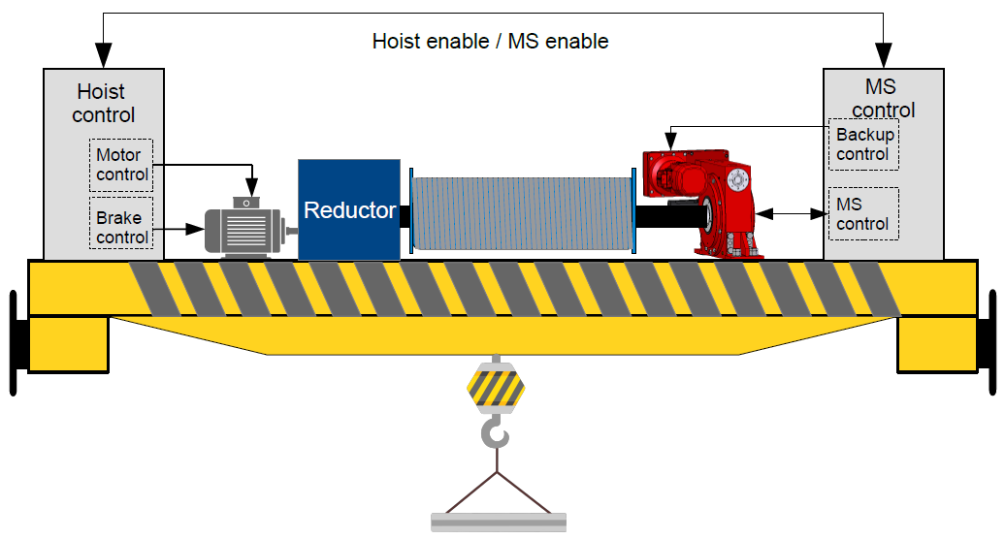

***Figure 1*** MotoSuiveur® general principle

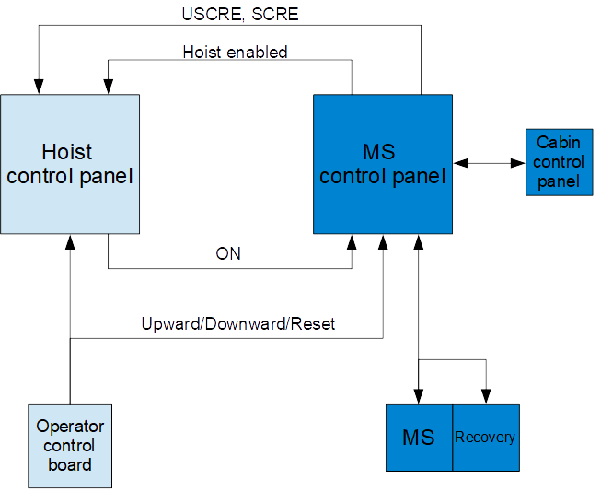

***Figure 2*** Block diagram of general MS principle

***Glossary***

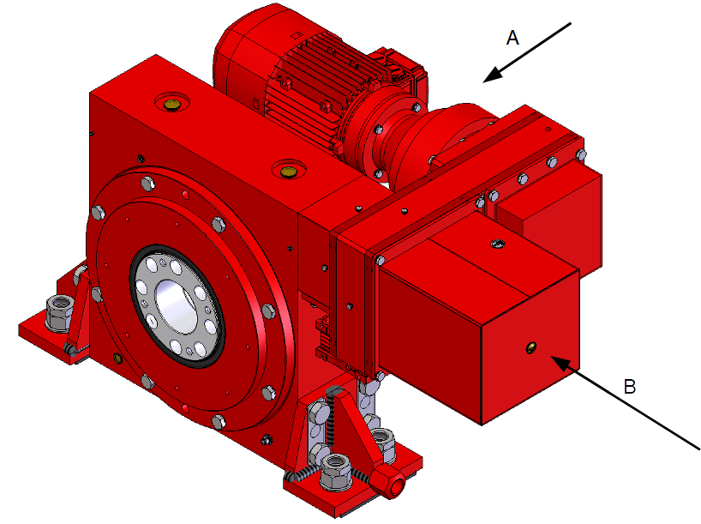

|  |  |  |
| --- | --- | --- |
| ***№*** | ***Name*** | ***Description*** |
| 1 | A | Perspective A |
| 2 | B | Perspective B |

***Figure 3*** MS unit general view

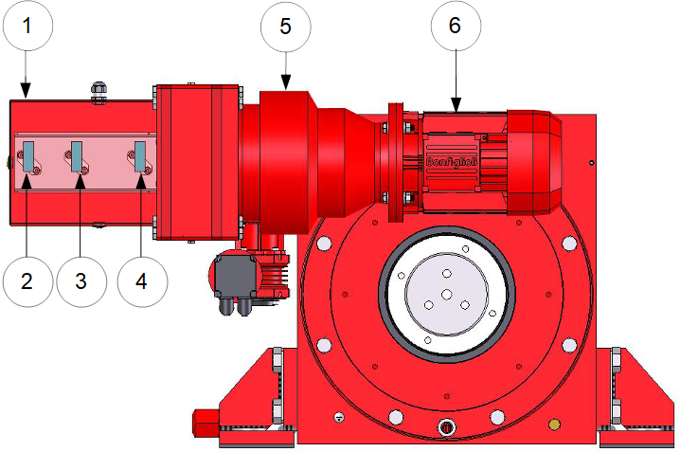

|  |  |  |
| --- | --- | --- |
| № | Name | Description |
| 1 | Position switches box | MS position switches |
| 2 | Screwing enable (SCRE) switch | Allows movement in screwing direction of worm |
| 3 | Unscrewing enable (USCRE) switch | Allows movement in unscrewing direction of worm |
| 4 | Recovery engaged switch | Indicate engaged recovery mechanism |
| 5 | Recovery reductor | Reductor of recovery mechanism |
| 6 | Recovery motor | Motor of recovery mechanism |

***Figure 4*** MS perspective A

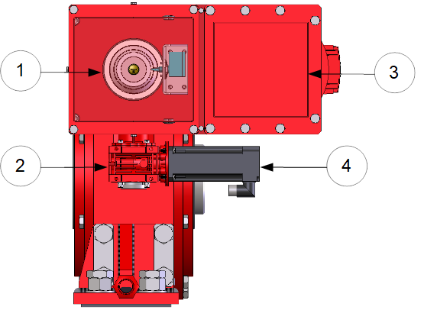

|  |  |  |
| --- | --- | --- |
| № | Name | Description |
| 1 | Worm | MS worm |
| 2 | Reductor of MS main (servo) motor | Reductor of MS motor |
| 3 | Terminal block box | Terminals for MS electrical parts connection |
| 4 | MS main (servo) motor | MS main motor |

***Figure 5*** Perspective B

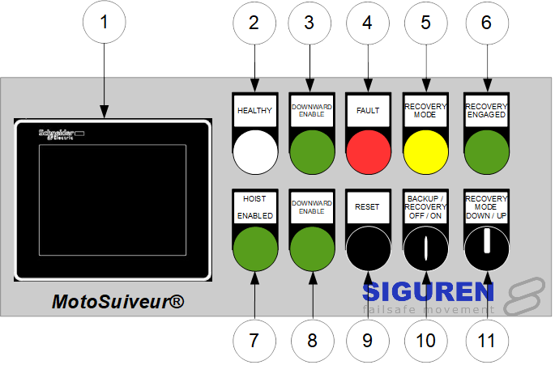

|  |  |  |
| --- | --- | --- |
| № | Name | Description |
| 1 | MSHMI | Operator HMI panel |
| 2 | HEALTHY | MS is electrically healthy |
| 3 | DOWNWARD ENABLE | Hoist is allowed to perform lowering movement |
| 4 | FAULT | MS is in fault state |
| 5 | RECOVERY MODE | Recovery mode is activated* |
| 6 | RECOVERY ENGAGED | Recovery mechanism is engaged* |
| 7 | HOIST ENABLED | Hoist is allowed to perform movements |
| 8 | DOWNWARD ENABLE | Hoist is allowed to perform lift movement |
| 9 | RESET | MS reset |
| 10 | BACKUP / RECOVERY OFF / ON | On and off Backup / Recovery mode* |
| 11 | RECOVERY MODE DOWN / UP | Recovery mode control* |

*\* MS Operating modes are explained in details further in document*

***Figure 6*** Crane control panel

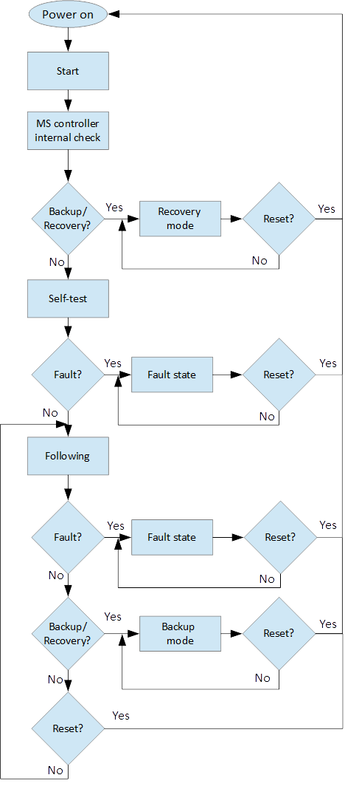

***Figure 7*** General view of the sequence of MS operation modes

Characteristics of MS are presented on the nameplate of the MS. The nameplate of the MS indicates the maximum rotating speed, the corresponding braking torque and other characteristics (mass, oil quantity, etc.). Example is shown on figure 8.

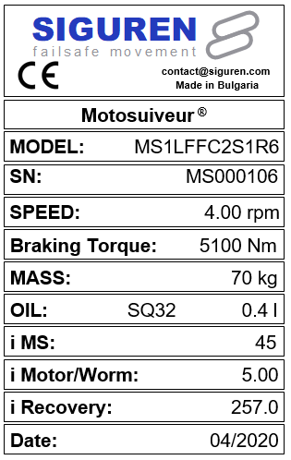

***Figure 8*** MS nameplate

***Connect MS to control cabinet***

After mechanical assembly of MS to hoist is done, electrical connection must be made between MS and control cabinet. Figure 7 shows general view of typical MS unit electrical components that should be connected according specific for the project electrical circuit diagram.

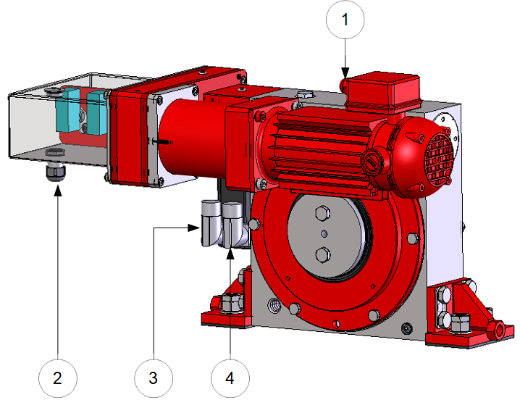

|  |  |  |  |
| --- | --- | --- | --- |
| № | Description | № | Description |
| 1 | C8 – Recovery motor connector | 3 | C6 – Power connector |
| 2 | TSW – Position switches terminal | 4 | C7 – Resolver connector |

***Figure 6*** Electrical connections of MS unit

Connectors C6 and C7 (figure 6 points 3 and 4) should be made according following specification:

* For C7 connector screened cable with 4 twisted pairs, 0.25 mm² should be used. Ground the shield of the feedback should be connected to GND – figure 7 a);
* For C6 connector should be used screened cable, 4 core, 1.5 mm². Ground the shield of the feedback should be connected to GND – Figure 7 b).

Figure 7 c) shows signal arrangement of connector on motor side for motor type Kollmorgen.

Figure 7 d) shows general MS motor view.

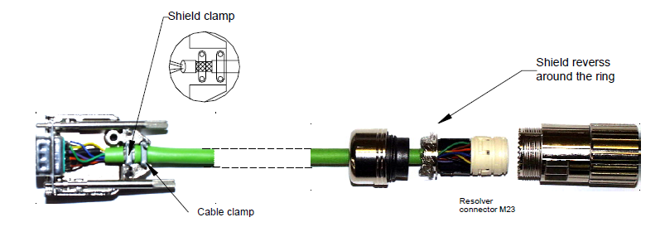

a) C7 connector

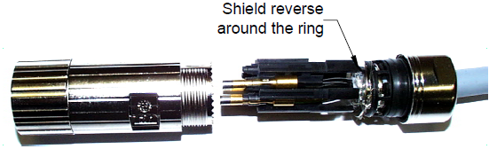

b) C6 connector

|  |  |  |  |  |  |  |
| --- | --- | --- | --- | --- | --- | --- |
| Connector | № | | Name | Description | | |
|  | 1 | | NC | Not connected | | |
| 2 | | TEMP- | Motor temperature sensor Lo | | |
| 3 | | COS- | Cosine Lo | | |
| 4 | | SIN- | Sine Lo | | |
| 5 | | REF- | Reference Lo | | |
| 6 | | TEMP+ | Motor temperature sensor Hi | | |
| 7 | | COS+ | Cosine Hi | | |
| 8 | | SIN+ | Sine Hi | | |
| 9 | | REF+ | Reference Hi | | |
| 10 | | NC | Not connected | | |
| 11 | | NC | Not connected | | |
| Connector | | № | | Name | Description |
|  | | 1 | | V | Motor phase V |
| 2 | | PE | Motor earth |
| 3 | | W | Motor phase W |
| 4 | | U | Motor phase U |
| A, B, C, D | | NC | Not connected |

c) Kollmorgen motor

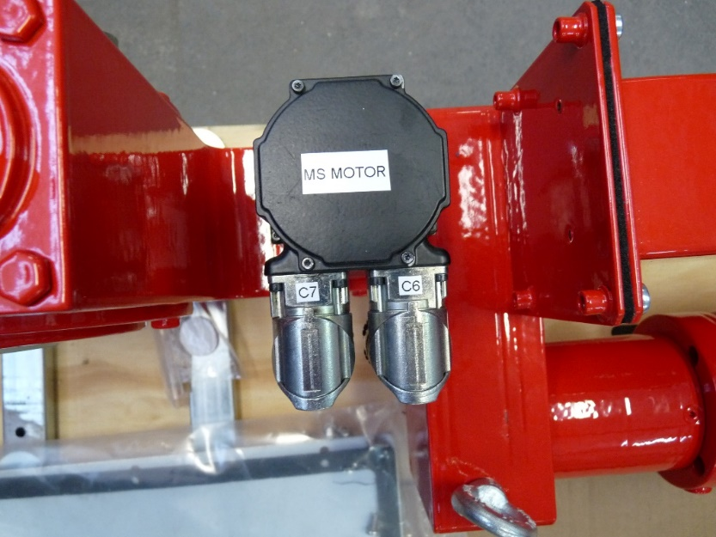

d) General view of MS motor

***Figure 7*** Connectors C6 and C7

|  |  |
| --- | --- |
|  | **ATTENTION** |
|  | ***C6 and C7 must be connected according specification! Wrong connection can cause motor damage!*** |

Connector C8 (figure 6, point 1) is MS recovery motor electrical connector. Recovery motor is DC motor controlled by Siguren motor controller MSRM4514. Working voltage of motor is 48VDC therefore is very important motor to be connected correct. Correct connection is shown on figure 8.

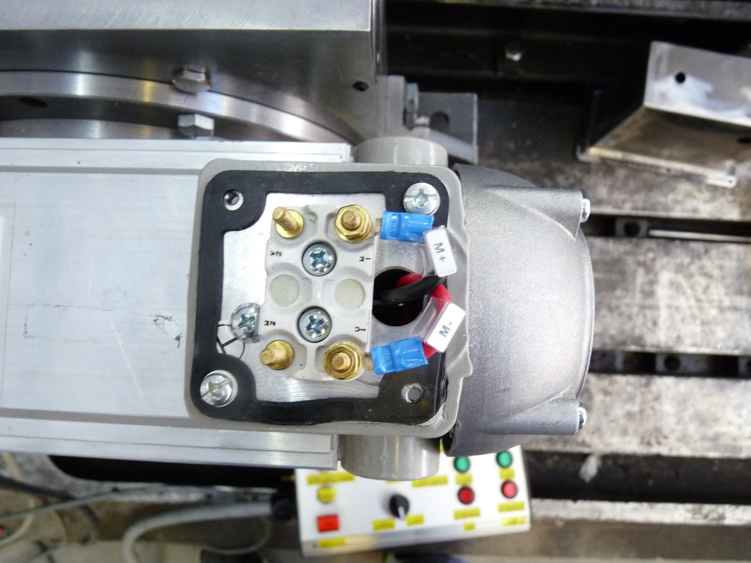

***Figure 8*** MS recovery motor C8 terminal connection

Position switches are used for allowing or prohibits hoist movement. Position switches are using in active output signal via NC contact. Signal from switches should be active in case when switches are not in contact with worm and worm is in correct position. Figure 9 a) combination of signals form position switches is shown. Position switches are shown on figure 9 b).

|  |  |  |  |
| --- | --- | --- | --- |
| SCRE | USCRE | Upward enable | Downward enable |
| Checkmark | Checkmark | Checkmark | Checkmark |
| Checkmark | Close | Checkmark | Close |
| Close | Checkmark | Close | Checkmark |
| Close | Close | N/A; MS controller fault; Switch fault | |
| Checkmark | - Active signal | | |
| Close | - Inactive signal | | |

a) combination of signals from position switches

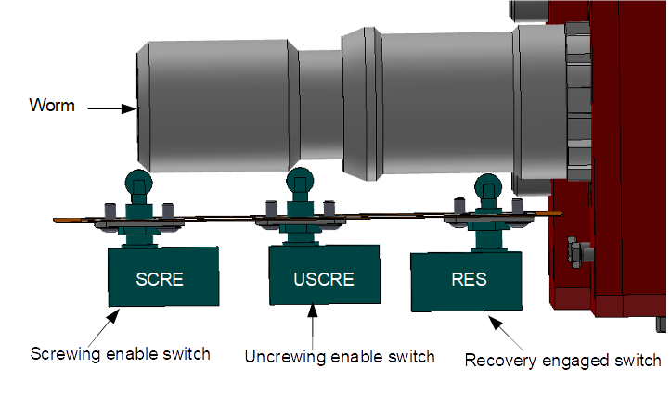

***b)*** position switches

***Figure 9*** Position mechanical switches

Terminal block TSW (Terminal SWitches) is used for connection of worm position proxy sensors/switches and control cabinet. Figure 10 shows general view of TSW and description of terminals.

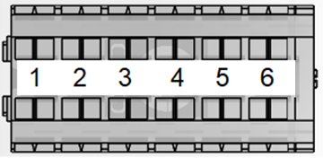

|  |  |
| --- | --- |
| № | Description |
| 1 | +24VDC. Supply USCRE position switch |
| 2 | Signal from USCRE position switch |
| 3 | +24VDC. Supply SCRE position switch |
| 4 | Signal from SCRE position switch |
| 5 | +24VDC. Supply Recovery position switch |
| 6 | Signal from position switch |

***Figure 10*** Termina block TSW

Terminal blocks in control cabinet are for connection between MS and control cabinet. Terminal blocks are described in Table 1.

***Table 1*** Control cabinet terminals

|  |  |
| --- | --- |
| Terminal block | Description |
| T1 | Power supply |
| T2 | Digital inputs |
| T3 | MS sensors/switches |
| T4 | Digital outputs |
| T5 | Analogue I/O |
| T6 | MS motor power supply |
| T7 | MS motor resolver |
| T8 | Recovery motor power supply |
| T9 | Heater |

Figure 11 shows general view of connection between MS and control cabinet (MSCC). For more detail about connection, please review electrical circuit diagram for the corresponding project.

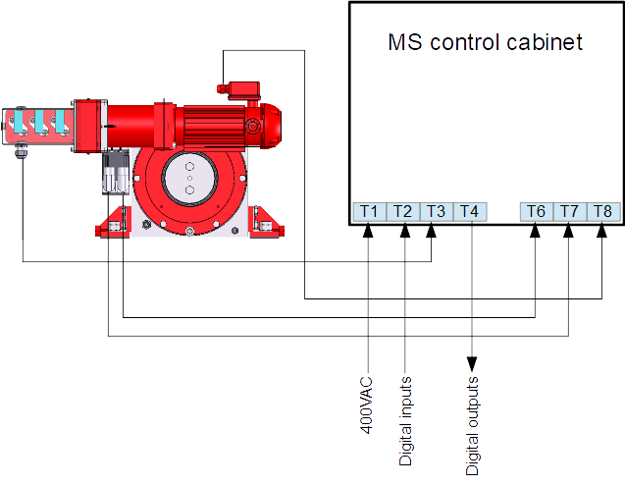***Figure 11*** General view of connection between MS and MSCC

***Indication lamps and controls***

*Indication lamps* and *local* *controls* are shown on figure 3. They are located on front door of control cabinet.

*Indication lamps* indicates:

- MS status – figure 3, items 2, 8;

- allowed movement direction of hoist – figure 3, items 1, 3, 9;

- recovery mode status – figure 3, items 10, 11.

*Local controls* are used for:

- reset of MS – figure 3, item 7;

- overrides MS enable signal (override ON signal) – figure 3, item 6;

- enable and control MS Backup/ Recovery mode – figure 3 items 4, 5, 10, 11.

Figure 12 shows schematically the control signals between hoist and MS.

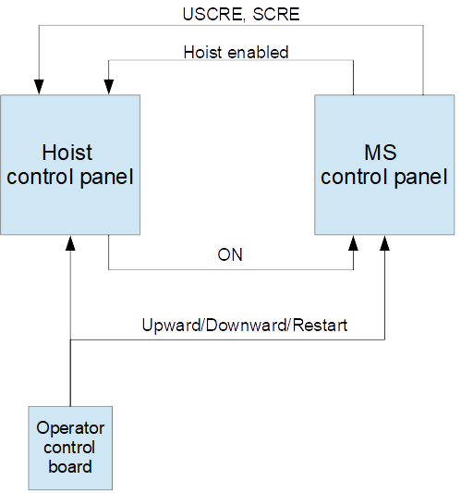

***Figure 12*** Control signals between hoist and MS

|  |  |
| --- | --- |
|  | **ATTENTION** |
|  | ***Local control commands can be duplicated with remotes! Please, check electrical circuit diagram!*** |

### ***Hoist enabled.***

*Hoist enabled* lamp indicate that the MS authorizes hoist movements. (figure 5). *Hoist enabled* signal will on only in case if ON signal from hoist is ON.

*Hoist enabled* signal will be ON when MS self-test pass successfully and ON signal is available then ***Hoist enabled*** and ***Healthy*** indicator lamps are on. The signals are indicating system ready (MS ready).

### ***Fault***

*Fault lamp* (figure 3, item 2) indicates three different types of faults:

- MS controller internal errors, described in section 7.1;

- MS faults (further called flt_num), described in section 7.2;

- MS warnings (further called wrn_num), described in section 7.2;

MS controller internal errors are related to MS controller internal hardware, firmware, and MS motor. This type of errors are with highest priority. If MS controller internal fault appear further operation is prohibited.

|  |  |
| --- | --- |
|  | **INFORMATION** |
|  | ***Fault lamp indicator is on during MS self-test.*** |

|  |  |
| --- | --- |
|  | **ATTENTION** |
|  | ***The system displays only last MS warning (wrn_num) or MS fault (flt_nim) occurred.*** |

Faults and warnings are displayed on MS 7 – segment controller. The display indicates all types of MS warnings/faults and MS controller internal errors. Indication is a combination of letters and numbers. MS controller internal faults are indicated with blinked combination of , number and finish with symbol 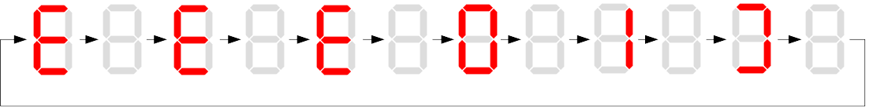.

MS faults are displayed with combination of and number. MS warnings are displayed with combination of  and number.

On figure 13 a) is shown example for internal MS controller fault. On figure 13 b) is shown example for MS warning.



a) MS controller internal error E01

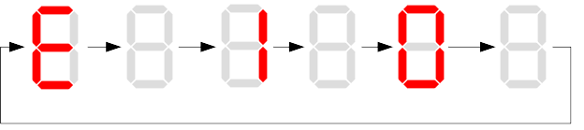

b) MS warning number 10 (wrn_num = 10)

***Figure 13*** Displaying messages on MS controller 7 – segment display

|  |  |
| --- | --- |
|  | **INFORMATION** |
|  | ***After MS reset, all types of faults are cleared. Before MS reset, fault should be resolved.*** |

### ***Upward enable/Downward enable***

*Upward enable/Downward enable* are indicators for authorized direction of hoist movement. If one of the two directions is forbidden to move, it is necessary to move the hoist in the opposite direction in order to reset the system mechanically.

Movements *upward* and *downward* of hoist are correspond to *screwing* and *unscrewing* movement of MS worm. Movement directions of worm are corresponding to directions of clock. Direction screwing is clockwise, unscrewing direction is anticlockwise, viewed from cam part of the screw shaft as is shown on figure 14.

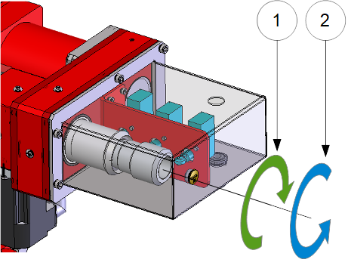

1 – Screwing direction

2 – Unscrewing direction

***Figure 14*** MS Worm rotating directions

|  |  |
| --- | --- |
|  | **ATTENTION** |
|  | ***After MS reset or manual centering of the worm and MS restart, no movement is performed or faults appears, please contact SIGUREN technologies on address support@siguren.com*** |

### ***Backup/Recovery Off/On; Backup/Recovery Down/Up***

*Backup* function allows the load to be lowered down, by using minimal functionalities when MS is in Following operation mode. *Backup* function ignore all settings related with nominal following operation mode and allows movement of the hoist with limited speed.

*Recovery* function is used when the main hoisting chain is faulty (for example damaged brake of the hoist motor). Recovery system allows lowering load safety to the ground.

### ***Enable Override***

*Enable override* can be used if it is necessary to override Hoist enabled. This allows small movements for MS mechanically reset.

### ***Lamp states***

Combination of active (ON) and inactive (OFF) signal lams gives current status of MS. In Appendix Table 1 signal combinations are presented and described.

***MS operating modes***

## ***MS controller internal check***

At power on (or restart) MS starts operating according figure 3. According sequence of MS operation modes first operation is MS controller internal check. Internal check is intended to hardware, firmware of MS controller, MS motor and MS motor resolver.

In case of fault, fault is visualized on 7 – segment display as described in 5.1.2. Further operations are prohibited. List with MS controller internal faults are listed in section 7.1.

***Self-test operation mode***

After MS controller internal check finishes, Self-test operation mode (further called self – test) starts. On figure 15 a) symbols indicated self-test steps on MS controller 7 – segment display are shown. On figure 15 b) is shown sequence of self-test steps.

|  |  |  |  |
| --- | --- | --- | --- |
| ***Symbol*** | ***Description*** | ***Symbol*** | ***Description*** |
|  | Homing |  | Un-screwing enable switch not made |
|  | Waiting piston return |  | Screwing enable switch not made |
|  | Blocked |  | Screwing enable switch not centered |
|  | Checking MS firmware (Soft) |  | Un-screwing enable switch not centered |
|  | Electrical test |  | Damping plus* |
|  | Switch test |  | Damping minus* |
|  | Damping* |  | Play minus |
|  | Air* |  | Play plus |
|  | Play | / | Error / Fault |
| * - *steps are applicable only for hydraulic MS*  a) Self-test steps symbols | | | |

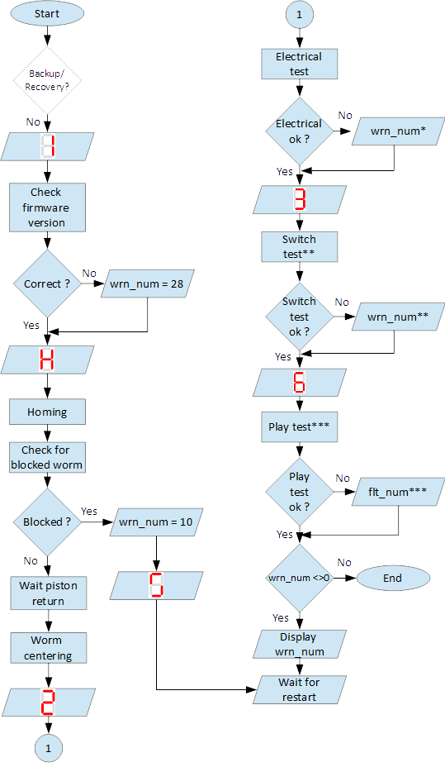

*Fields with *, ** and *** are related with Table 2 in section 7.2*

b) sequence of self-test steps

***Figure 15*** *Self – test* operation mode

### ***Electrical test***

On figure 16 steps of *Electrical test* are shown. Test checks for active signals on inputs of the MS controller before self-test begin.

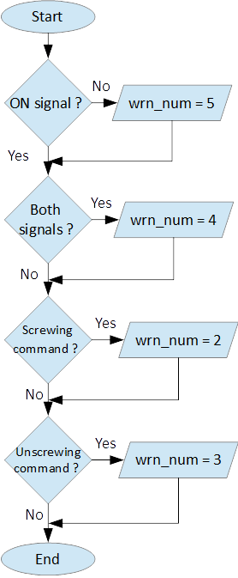

***Figure 16*** Steps of *Electrical test*

|  |  |
| --- | --- |
|  | **ATTENTION** |
|  | ***In case of repetitive faults, please contact SIGUREN technologies on address support@siguren.com!*** |

### ***Switch test***

*Switch test* check connection between MS controller and SCRE/USCRE switches (figure 2, items 4, 5), centered position and functionality of switches. On figure 8 are shown steps of *Switch test*. In Table 2 located in appendix are shown steps for visual check of *Switch test*. Visual check of *Switch test* is necessary only in case if repetitive faults during the test appears.

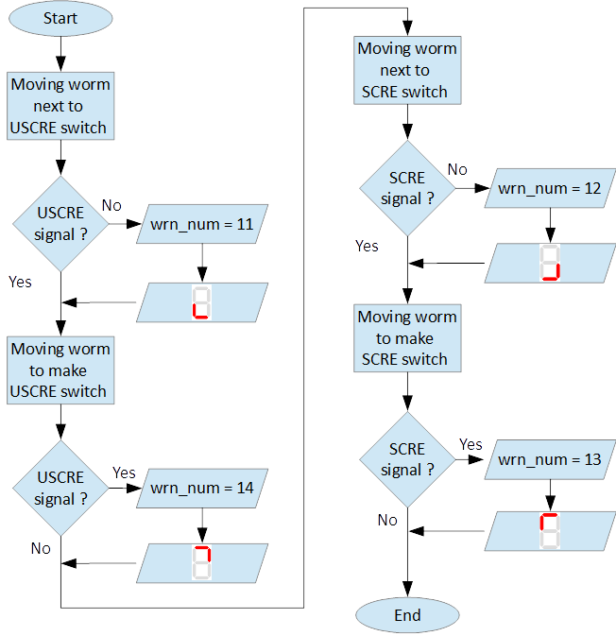

***Figure 17*** Steps of *Switch test*

|  |  |
| --- | --- |
|  | **INFORMATION** |
|  | ***In case of repeatedly wrn_num occurs, please check:***   * ***connection between MS control cabinet and SCRE/USCRE switches;*** * ***functionality of SCRE and USCRE switches;*** * ***- signals on inputs of MS controller and operational relays RSESw and RUESw located in MS control cabinet;*** |

### ***Play test***

*Play test* measures play between worm and worm wheel. On figure 18 steps of *Play test* are shown.

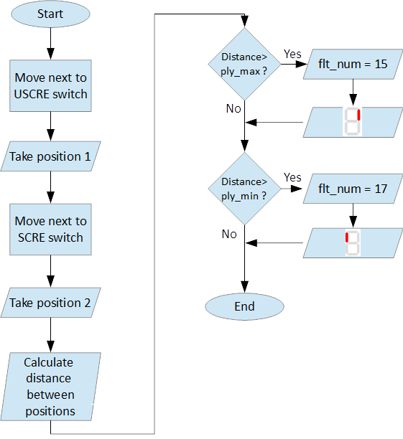

***Figure 18*** *Play test* steps

|  |  |
| --- | --- |
|  | **ATTENTION** |
|  | ***In case of repetitive faults, please contact SIGUREN Technologies on address support@siguren.com!*** |

***Following operation mode***

*Following operation mode* starts after successful passed of self – test. The function of this operation mode is intended for follow movements of the hoist and to monitor for exceeding the rated speed (nominal speed) with defined positive tolerance. The speed, which is considered high is called *Overspeed*. By design MS will not allow *Overspeed*. Typically O*verspeed* is equal to:

Overspeed = Nominal speed + 10% (1)

Figure 19 is presents main principle of *Following operation mode* and overspeed detection. On figure 20 steps of following operation mode is presented. On figure 21 are shown symbols displayed on 7 – segment display during following operation mode.

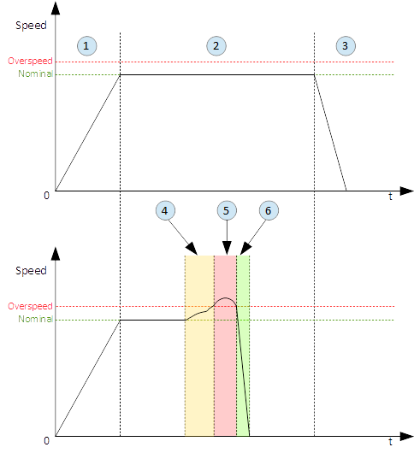

|  |  |
| --- | --- |
| 1 – Acceleration | 4 – Exceeding nominal speed |
| 2 – Following | 5 – Overspeed detection |
| 3 – Deceleration | 6 – Overspeed detected. MS is breaking |

***Figure 19*** Main principle of following operation mode and overspeed detection

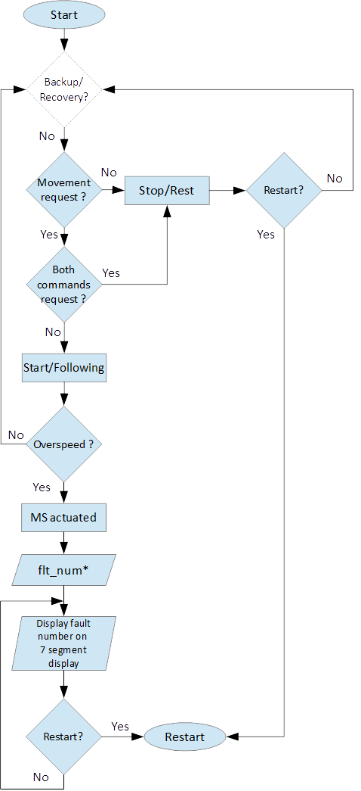

***Figure 20*** Principle of Following operation mode

|  |  |
| --- | --- |
| ***At rest*** | |
| Symbol | Description |
|  | Unscrewing enable switch sctivated |
|  | Screwing enable switch activated |
|  | Both commands  activated |
|  | Maintenance “A” |
|  | Maintenance “B” |
|  | Maintenance “C” |
|  | Maintenance “D” |
|  | Rest (normal) |

|  |  |  |
| --- | --- | --- |
| ***During movement*** | | |
| Symbol | Description | Explanation |
|  | Centering | The worm is positioned to the center of its backlash, to prepare for the next  movement |
|  | Screwing Tackling | Upward movement start |
|  | Unscrewing  Tackling | Downward movement start |
|  | Screwing  Following | Upward movement following |
|  | Unscrewing  Following | Downward movement following |
|  | Near Overspeed | Starts blinking the more and more rapidly as the speed approaches the  'overspeed' threshold setting |
|  | Near Underspeed | Starts blinking the more and more rapidly as the speed approaches the  'underspeed' threshold setting |
|  | Fault | Fault detected |

***Figure 21*** Symbols displayed on 7 – segment display on MS controller

***Backup/Recovery operation mode***

*Backup/Recovery* operation mode functions are intended to unusual situations during MS operating. Controls and indicators of this functions are located on control panel front door – figure 3, items 4, 5, 10, 11.

On figure 23 is shown principle of Backup/Recovery operation mode. Backup/Recovery decision figures located in figures 15 and 20 with dotted outline, represent the places where request for these operation modes are checked.

Switching on Recovery/Backup mode is performed through Backup/Recovery OFF/ON key – figure 2, item 4. After switching Backup/Recovery mode on, *Backup mode* start operating. On 7 – segment display indication for backup mode is displayed  and *Recovery mode* lamp is on. Backup function ignore all settings related with following operation and allows movement of hoist with hoist limited speed.

In Backup operating mode, control is performed trough commands for lifting and lowering of the hoist. In case of hoist control chain is damaged, control can be performed manually directly on control terminals located in MS control cabinet via wire bridge. Example is shown on figure 22. In *Backup mode* no ON signal is required to perform movement of MS.



***Figure 22*** Example for manual operation in backup mode

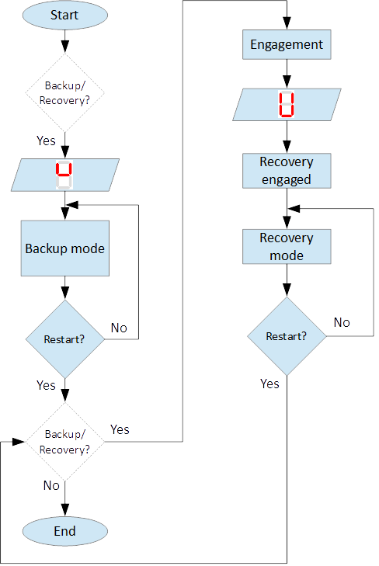

***Figure 23*** Principle of Backup/Recovery operation

Recovery mode is second part of *Backup/Recovery operation*. This mode start operates the way is shown on figure 23. After reset, MS checks for active *Backup/Recovery mode* request (*Backup/Recovery operational key* is ON). If request is active 7 – segment display shows symbol for Recovery mode  and engagement start. Engagement function is used to engage recovery mechanism to the worm via recovery nut – figure 1, item 7.

Completion of engagement is indicated by Recovery engaged indication lamp (figure 3, point 10). If lamp is off after first engagement, reset is needed. Reset will activate engagement again.

Controlling of Recovery is with 3 – position key *Backup/Recovery Down/Up* located on front door of control cabinet – figure 3 item 5. Also Recovery can be controller remotely if that is provided by electrical circuit diagram.

After engagement is complete and Recovery engagement lamp is on, brake of main hoist motor should be released. Otherwise motor brake will prohibit movements. Brake should remain open until recovery operation done.

For disengagement, load should be on safe place, main hoist motor brake should be closed. Command for lowering should be given to MS until both lamps for Upward enable and Downward enable becomes on.

|  |  |
| --- | --- |
|  | **ATTENTION** |
|  | ***Recovery function is mainly designed for safety lowering of the load. Function allows very short lifting of the load only in case if it is absolutely necessary!*** |

|  |  |
| --- | --- |
|  | **ATTENTION** |
|  | ***Before activating Backup/Recovery operation mode from local controls (figure 3, item 4), please make sure that operation mode is not activated remotely. The verification consists of the following steps:***   * ***Recovery mode lamp and Recovery engaged lamp are off;*** * ***Backup/Recovery control key is in position “0” (OFF);*** * ***On 7 – segment display symbols***  ***or***  ***are not displayed.*** |

***Troubleshoot and maintenance***

Troubleshooting of MS can be done by few ways:

- via signal lamps located on front door – Appendix 1;

- via MS controller 7 – segment display – section 6.1;

- via touchscreen HMI (MSHMI) – section 6.2.

***Troubleshooting via MS controller 7 – segment display***

### ***MS controller internal errors***

|  |  |  |
| --- | --- | --- |
| ***Message*** | ***Description*** | ***Possible cases*** |
| E01 | DC bus overvoltage: An overvoltage has been detected on the internal DC bus. | This fault may be due to overvoltage on the network or due to overloaded ballast resistor. |
| E02 | Undervoltage DC Bus: The internal DC bus has dropped below the configured minimum voltage. | This fault is managed while the drive is enabled. |
| E03 | I²t motor: Overload on the motor. | Mechanical hard point, bad power wiring, motor feedback problem, poorly controlled brake. |
| E04 | Overcurrent: A current greater than the maximum measurable current has been detected on at least one of the motor phases. | The drive must be powered 24VDC for 15 min before it can be unlocked. |
| E05 | Short circuit: A short-circuit between phases or the earthing of a motor phase has been detected. | The drive must be powered 24VDC for 15 min before it can be unlocked. |
| E06 | IGBT temperature: maximum temperature reached in the drive. | It is impossible to acknowledge the fault until the temperature has gone back down. |
| E07 | Motor temperature: maximum temperature reached in the motor. | It is impossible to acknowledge the fault until the temperature has gone back down. |
| E08 | Resolver fault: Defective resolver signals. | Check resolver connection between motor and control cabinet and resolver connector. |
| E09 | Coil temperature: maximum temperature reached in the self. | It is impossible to acknowledge the fault until the temperature has gone back down. |
| E16 | Resolver saturation: Sin / Cos resolver signals received too high. | Check resolver connection between motor and control cabinet and resolver connector. |
| E17 | 24V auxiliary supply error. | This fault is triggered if the 24V auxiliary power supply is noisy or has a voltage dip (<15V). Check the 24V supply. |

### ***MS faults and warnings***

|  |  |  |
| --- | --- | --- |
| ***Message*** | ***Description*** | ***Possible cases*** |
| E02 | Screwing command during self-test * | Check for pressed/held down button for hoist lifting command. |
| E03 | Unscrewing command during self-test * | Check for pressed/held down button for hoist lowering command |
| E04 | Both commands during self-test * | Check for pressed/held down button for hoist lifting and lowering command |
| E05 | ON signal missing during self-test * | ON signal from hoist missing (figure 12). Check electrical connection between hoist control cabinet and MS hoist cabinet. ON signal from hoist to MS is available Check hoist control |
| E10 | Blocked worm | Worm is locked to recovery mechanism. Worm is stuck. Mechanical reset is needed. In case of Downward enable off after recovery operation, moving I opposite side from hoist is needed. Moving should continue until lamps indicators for upward and downward are on. After manual reentering, MS reset is necessary. |
| E11 | Unscrewing enable switch not centered ** | Switch USCRE is not in correct position. Visual check is and centering is needed |
| E12 | Screwing enable switch not centered ** | Switch SCRE is not in correct position. Visual check is and centering is needed |
| E13 | Unscrewing enable switch not made ** | USCRE switch is not reached from worm during Switch test. Visual check is needed. |
| E14 | Screwing enable switch not made ** | SCRE switch is not reached from worm during Switch test. Visual check is needed. |
| E28 | Incorrect MS firmware version | Please, contact Siguren technologies |
| F15 | Worm backlash too big detected (Play too big) *** | Worm play is greater than defined. |
| F17 | Worm backlash too small detected (Play too small) *** | Worm play is smaller than defined. |
| F33 | Unscrewing Overspeed. Overspeed during lowering | Hoist speed exceeds maximum defined speed during lowering |
| F34 | Screwing Overspeed. Overspeed during lifting | Hoist speed exceeds maximum defined speed during lifting |

|  |  |
| --- | --- |
|  | **ATTENTION** |
|  | ***In case of repetitive faults, please contact SIGUREN Technologies on address support@siguren.com!*** |

***MSHMI***

The MSHMI is a Schneider Magelis HMI STU 655/855 color graphic touchscreen terminal programmed with the MSHMI firmware by Siguren technologies. MSHMI communicates with MS controller via MODBUS RTU protocol – figure 24.

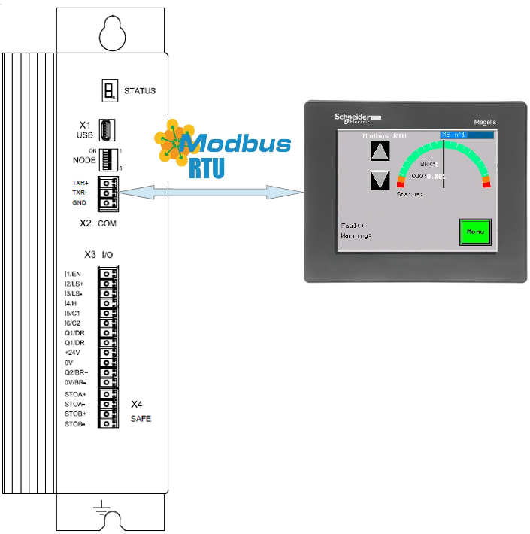

***Figure 24*** MSHMI

Advantages if using MSHMI to operating with MS® are:

- Display MotoSuiveur® status information in the form of messages, event listings, graphics and numerical values;

- Change the MotoSuiveur® configuration. Configuration is a secure access code at different levels;

- Change operating mode of MotoSuiveur®;

- Display maintenance information of MotoSuiveur®.

|  |  |
| --- | --- |
|  | **INFORMATION** |
|  | ***MSHMI is not part from standard MS equipment and can be ordered additionally.*** |

***Maintenance***

Due to inherent dangers in the maintenance and testing of electrical equipment, special attention should be paid to safety, not only to the personnel working the immediate area but also to equipment under test, maintenance and repair.

All personnel operating in the relevant area should observe these procedures and pay due regard to safety Local Safety Rules and Regulations.

It is advisable that at least two fully trained engineers be present at all times when the equipment is being tested, maintained or serviced.

All equipment under electrical test should have WARNING NOTICES displayed saying that equipment tests are in progress. Any ancillary equipment, for example, test equipment and instruments, should be safe and prominent notices around the equipment should advertise any danger, which may exist. Any notices displayed in pursuing these procedures should be removed as soon as they are no longer applicable, to emphasize the special significance of their presence.

If it becomes necessary to carry out maintenance, testing or setting up to work on the equipment requiring access by opening doors, removing covers etc., then safety hazards may arise. Then risk assessments should be carried out and safe-working practices followed.

A duty holder should be responsible for ensuring that the equipment is made accessible only to authorized personnel to carry out specific tasks after receiving permission.

The user should ensure that maintenance setting up and authorized and competent persons only carry out testing of the equipment. The following basic rules should be adhered to:

1. Before commencing maintenance works, the supply to the equipment must be isolated, locked off and the appropriate safety documents issued.

2. Comply with safe working conditions.

3. Do not work on the equipment when it is energized.

4. Ensure that all persons working on the equipment are familiar with instructions and information provided in this manual.

5. Providing that the equipment is functioning correctly and all personnel responsible for operating it are complying with the conditions specified, the electrical equipment may be deemed to be “properly used” and should be safe and free from health hazards.

The reliability of the Motosuiveur® will depend if the maintenance procedure is strictly adhered to. Maintenance operations are to be done based either on the Maintenance type displayed on MS controller 7 – segment display or on a time basis wherever the smallest value applies.

Maintenance Intervals: - A= Weekly, B= Monthly, C= 3 Monthly, D= 6 Monthly E= Annually, F= 2 Years, G=5 Years, H=10 Years

***Table 2*** MS maintenance intervals

|  |  |  |  |  |  |  |  |  |  |  |
| --- | --- | --- | --- | --- | --- | --- | --- | --- | --- | --- |
| **MotoSuiveur® Unit** | A | B | C | D | E | F | G | H | Worm Rotation Count (HMI) | Controller 7-Segment Display |
| MS fixation to barrel and to hoist structure |  |  |  |  | ⚫ |  |  |  | 75E6 | ; ; ; |
| Visual inspection. Check Fasteners, etc. | | | | | | | |  |  |
| MS Motor Transmission Grease:  REPSOL NLGI 00 |  |  |  |  | ⚫ |  |  |  | 75E6 | ; ; ; |
| Add or Replace if necessary | | | | | | | |  |  |
| Oil Level  SIGUREN MS Oil SQ32 |  |  |  |  | ⚫ |  |  |  | 75E6 | ; ; ; |
| Visual inspection. Add if necessary. | | | | | | | |  |  |
| Worm Outer Piston Assy  Part No: MSL-01-P04 |  |  |  |  |  |  | ⚫ |  | 150E6 | ; ; |
| Replace * | | | | | | | |  |  |
| MS Oil  SIGUREN MS Oil SQ32 |  |  |  |  |  |  |  | ⚫ | 450E6 | ; |
| Replace. Clean magnet plugs. | | | | | | | |  |  |
| Wheel Lip Seal NBR 70 Sh A  Reference: 100x120x7.5 |  |  |  |  |  |  |  | ⚫ | 900E6 |  |
| Replace * | | | | | | | |  |  |
| O-Rings NBR 70 Sh A  References: 200x2; 53x4 |  |  |  |  |  |  |  | ⚫ | 900E6 | D |
| Replace * | | | | | | | |  |  |

*\* Replace earlier if leaks are present and maintenance history is unknown*

***Table 3*** Integrated recovery mechanism maintenance intervals

|  |  |  |  |  |  |  |  |  |  |  |
| --- | --- | --- | --- | --- | --- | --- | --- | --- | --- | --- |
| **Integrated Recovery system of MotoSuiveur® Unit** | A | B | C | D | E | F | G | H | Worm Rotation Count (HMI) | Controller 7-Segment Display |
| Fixation to MS Unit |  |  |  |  | ⚫ |  |  |  | 75E6 | ; ; ; |
| Visual inspection. Check Fasteners | | | | | | | |  |  |
| Recovery Transmission Grease:  REPSOL NLGI 00 |  |  |  |  |  |  | ⚫ |  |  |  |
| Add or Replace if necessary | | | | | | | |  |  |
| IR system engagement |  |  |  |  | ⚫ |  |  |  | 75E6 | ; ; ; |
| Test Engagement / Disengagement Function | | | | | | | |  |  |

*\* Replace earlier if leaks are present and maintenance history is unknown*

# ***Appendix 1: Signal Lamps***

***Table 1*** Combination of active and inactive signal lams

|  |  |  |  |  |  |  |
| --- | --- | --- | --- | --- | --- | --- |
| **Signal lamp** | | | | | **Status** | **Correction** |
| **Fault** | **Enabled** | **Healthy** | **Recovery mode** | **Recovery engaged** |
| 0 | 0 | 0 | 1 | 0 | MS Power off. Recovery pre-engaged | Check MS electrical equipment and MS power supply. Check for fault or warning number. |
| 0 | 0 | 0 | 1 | 1 | MS Power off. Recovery engaged (Recovery mode) | Check MS electrical equipment and MS power supply. Check for fault or warning number. |
| 0 | 1 | 0 | 0 | 0 | Not allowed (Indication for hardware problem) | Check electrical equipment. Check for fault or warning number. |
| 1 | 0 | 0 | 0 | 0 | MS Hardware fault. (wiring, power supply, etc.) | Check MS fault number. |
| 1 | 1 | 0 | 0 | 0 | Not allowed (Indication for hardware problem) | Check MS electrical equipment. Check for MS fault or warning number. |
| 0 | 0 | 1 | 1 | 0 | Self-test or recovery pre-engagement | - |
| 0 | 0 | 1 | 1 | 1 | Self-test or recovery mode | - |
| 0 | 1 | 1 | 0 | 0 | Normal (ready or following) | - |
| 1 | 0 | 1 | 0 | 0 | MS Fault (overspeed, self-test, etc.) | Check fault or warning number. |
| 1 | 1 | 1 | 0 | 0 | Not allowed (Indication for hardware problem) | Check electrical equipment. Check for fault or warning number. |

|  |  |
| --- | --- |
| **Legend:** | |
|  | Mandatory signals/indicators |
|  | Optional signals/indicators |

***Table 2*** Visual check of switch test

|  |  |  |
| --- | --- | --- |
| ***Step*** | ***Picture*** | ***Description*** |
| Start |  | Initial centered position of the worm. |
| Moving next to USCRE switch |  | Worm is moved next to USCRE switch. |
| USCRE signal ? |  | Check for the presence of USCRE signal on input 2 of MS Controller. Upward enable lamp should be on. |
| Moving worm to press USCRE switch |  | After worm pressed switch, USCRE signal should be inactive. |
| USCRE signal ? |  | After worm pressed switch, Upward enable lamp should be off |
| Moving next to SCRE switch |  | Worm is moved next to SCRE switch. |
| SCRE signal ? |  | Check for the presence of USCRE signal on input 3 of MS Controller. Downward enable lamp should be on. |
| Moving worm to press SCRE switch |  | After worm pressed switch, SCRE signal should be inactive. |
| SCRE signal ? |  | After worm pressed switch, Downward enable lamp should be off. |
| End |  | Center worm between switches. Downward enable and Upward enable lamps should be on. |

***Appendix 2: Spare parts***

***Electrical spare parts***

***Table 1*** List with electrical spare parts

|  |  |  |  |
| --- | --- | --- | --- |
| ***Qty*** | ***Item*** | ***Manufacturer*** | ***Reference*** |
| 5 | Relay 24VDC, 1CO | Phoenix Contact | PLC-RSC-24DC/21 |
| 2 | Relay 24VDC, 2CO | Phoenix Contact | PLC-RSC-24DC/21-21 |
| 2 | Relay 24VDC, 4CO | Phoenix Contact | RIF-2-RPT-LDP-24DC/4X21 |
| 1 | 3 ph.AC/DC power supply 400AC/24VDC/480W | Delta Electronics | DRP024V480W3BN |
| 1 | AC transformer | Dimat-Ganchevi | 400VAC/230VAC/1200W |
| 1 | Fuse | Busman | 10.3 x 38/10A |
| 1 | MS Controller | Siguren | MSD 02/230VAC/5A |
| 1 | Recovery Controller | Siguren | MSRM4514 |
| 1 | Resolver Adaptor | Siguren | MSRES09 |
| 1 | D-Sub 9 pin cable - 2m | Male-Female straight | DSUB 9pin M-F |
| 3 | Roller Microswitch M12x1 | Pizzato | MK V11D15 |
| 1 | MS Motor resolver cable | Siguren | M23-RES – 3m |
| 1 | MS Motor power cable | Siguren | M23-PWR – 3m |
| 1 | Multifunctional time relay | Schneider | 24Vdc A9E16069 |
| 4 | M22-LED-G | Eaton | Led lamp indicator green |
| 1 | M22-LED-W | Eaton | Led lamp indicator white |
| 1 | M22-LED-R | Eaton | Led lamp indicator red |
| 1 | M22-WS/216881 | Eaton | 2 position key switch |
| 1 | M22-KC10/216380 | Eaton | 3 position key switch |
| 1 | M22-XD-S + M22-A + M22-KC10 | Eaton | 1NO push button |

***Mechanical Spares Parts***

***Table 2*** List with mechanical spare parts

|  |  |  |  |  |  |
| --- | --- | --- | --- | --- | --- |
| ***Item*** | ***Qty*** | ***Description*** | ***Manufacturer*** | ***Ref*** | ***Periodic replacement*** |
| 1 | 1 | MS1F Bevel Gear Set i=5 | Siguren | MSL-01-L411/L421 | No |
| 2 | 1 | Needle Bearing | Standard | AXK 2542 with 1 AS Washer | No |
| 3 | 1 | Outer Elastomer Washer | Siguren | MSL-01-S04-05 | 5 years |
| 4 | 1 | Inner Elastomer Washer | Siguren | MSL-01-S01-02 | 10 years |
| 5 | 1 | MS Motor | Kollmorgen | AKM21C-ACBNR00 | No |
| 6 | 1 | Recovery Motor | Bonfiglioli | BC220-B5-8Z71A32802 | No |
| 7 | 1 | Outward Piston Assy | Siguren | MSL-01-P04 | 5 years |
| 8 | 1 | Inward Piston O-Ring | Siguren | 53х4 NBR 70 Shore-A | 10 years |
| 9 | 2 | Magnet Drain plug | Siguren | Magnet plug M16x1.5 | No |
| 10 | 2 | Wheel lip seal | Standard, NBR 70 Sh A | 100x120x7.5 WASY | 10 years |
| 11 | 2 | Wheel plug o-ring | Standard | 200х2 70 Shore-A | No |
| 12 | 1 | Recovery gearbox | Bonfiglioli | LC 090 2 100 STD 95A CD 11 KE | No |
| 13 | 2 | Wheel bearing | Standard deep groove ball bearing | DIN 625-1  Ø100xØ150x24 | No |

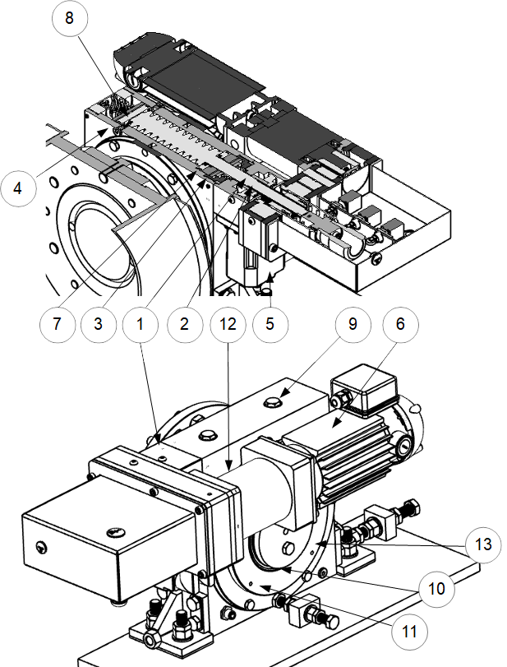

***Figure 25*** MS spare parts locations

***Appendix 3: Technical data***

***MS Motor***









***Recovery motor***





